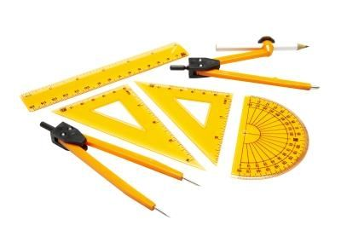
Engineering
Engineering Firm
Draftsman | Date: ____ ____ /____ ____ /____ ____
Project Manager | Date: ____ ____ /____ ____ /____ ____
Scale: 1/2 inch /unit square | Plan Draft Ready for production
Design sheet

